Practical - 14
Practical Title:Admin Dashboard with Role-Based Access Control, Dynamic Menu, and Audit Log
Develop an admin dashboard that displays user statistics, student count,
event count and latest registrations. Restrict access to admin users only
and show dynamic menu options based on role.

Theory
1. Are dashboard values loaded dynamically from the database?
Yes, key metrics, summary counts, and record tables on the dashboard are queried dynamically from MySQL database tables and rendered on page load.
2. Is access restricted to admin users?
Yes, access control logic checks active session privileges and restricts administrative panels specifically to users with authenticated admin roles.
3. Are role-based menus working?
Yes, navigation menus adapt dynamically based on user roles, rendering administrative options for admins and standard portal links for student accounts.
4. Are important admin actions recorded in audit_logs?
Yes, critical administrative operations like record creations, updates, and deletions automatically trigger log entries in an audit_logs database table for tracking.

Output
- Connected dashboard widgets directly to SQL queries to display live, dynamic system statistics and user data.
- Implemented strict role-based access control (RBAC) to restrict administrative routes and customize navigation menus according to user privileges.
- Created automated logging routines to track administrative actions and write system modifications to an audit_logs database table.

To View Code: https://github.com/shreyajodhani/studenthub.git

Evidence of Work (Screenshots)
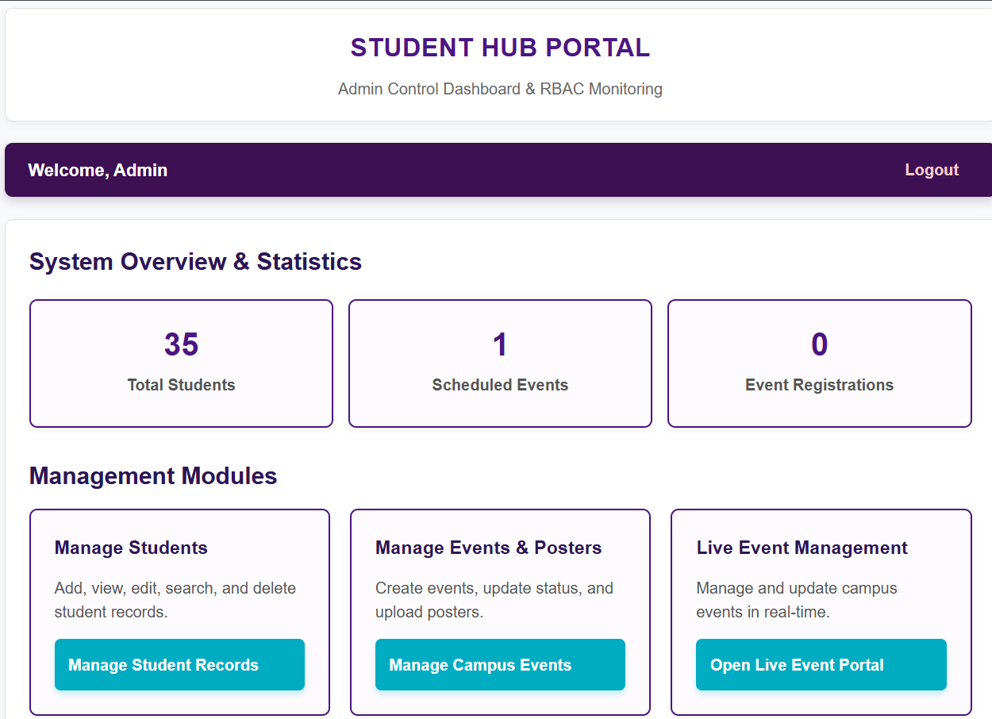
Description: Page displaying student count, registration count, events.

GitHub Repository Link: https://github.com/shreyajodhani/studenthub.git

Challenges Faced:

To restrict student logins in the admin panel.

Learning Outcomes:
To show option on based of roles only.
Faculty Remarks: (Keep this blank for faculty)

